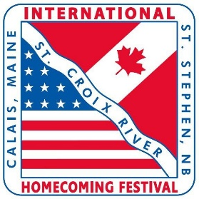
49th Annual International Homecoming Festival
EVENT BROCHURE APPLICATION

Event Organizers are invited to supply a brief description of their event, along with date, time, location and contact details to appear in the brochure. Applications are subject to approval for brochure submission.
Please complete this form in its entirety and email it or deliver it to:
Canadian Side: Patty Anderson, patty.anderson@chocolatetown.ca or drop it off at the
Town Hall main desk - attention “International Festival”
Completed forms will only be accepted until June 15th, 2022, for submission to brochure. Event applications submitted after this date will be considered for online promotions.

EVENT TITLE: ________________________________________________________________________
LOCATION OF EVENT: __________________________________________________________________
DATE AND TIME OF EVENT: _____________________________________________________________
BRIEF DESCRIPTION OF THE EVENT: ______________________________________________________
____________________________________________________________________________________
____________________________________________________________________________________
____________________________________________________________________________________
ORGANIZER/CONTACT NAME AND PHONE NUMBER: _________________________________________
EMAIL: ______________________________________________________________________________
May we display your email in the brochure? ________________________________________________
SIGNATURE OF EVENT ORGANIZER/CONTACT PERSON: _______________________________________

INTERNAL COMMITTEE USE ONLY:
APPLICATION RECEIVED: _____________________ CONFIRMED WITH CONTACT:__________________
(mm/dd/yy) (mm/dd/yy)

