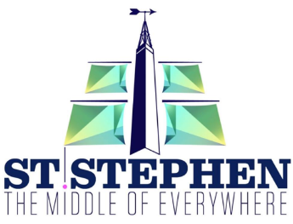
New Brunswick Day Battle of the Bands August 1, 2022

Rules and Conditions
- All participants must be residents of the province of New Brunswick
- All participants must audition. Please forward a video audition to pamela.williams@chocolatetown.ca This video does not have to be of professional quality.
All decisions by the selection committee are final
- Audition videos/tapes must be received by 12:00pm July 1st, 2022.
- There are NO categories or age groups. Everyone competes together
- The use of offensive language, clothing, or song selection is STRICLY PROHIBITED. This is an inclusive family orientated all ages event.
- Order of appearance will be decided by selection committee. All decisions are final.
- This is a judged event. All selected artists/bands will perform after which the Judges will award 1st and 2nd place. 3 Judges will be named at a later date. All Judges decisions are final.
- All participants are responsible for their own equipment. The Garcelon Civic Center and Town of St. Stephen are not responsible for lost or stolen items.
- Equipment/instruments may NOT be left overnight at the Garcelon Civic Center. Equipment may be brought in the morning of the event and must be removed following the event that evening.
- There will be NO compensation for expenses. Prize money will be awarded to 1st place and 2nd place only.
- Alcohol or drug use on stage is STRICLY PROHIBITED. There will be a beer garden on site all alcohol must be confined to that area.
- Length of performance will depend on the amount of artists/bands performing. A minimum set of 30 minutes is expected to a maximum of 1 hour.
- Once your set is complete, you must leave the stage in a timely professional manner.

Artist/Band information (PLEASE PRINT)
Contact name:_____________________________________________________________________
Phone number:____________________________________________________________________
Address:__________________________________________________________________________
Band Name:___________________________________Hometown:__________________________
Email:____________________________________________________________________________
Names of Band members:____________________________________________________________
Social Media site (if applicable):________________________________________________________

