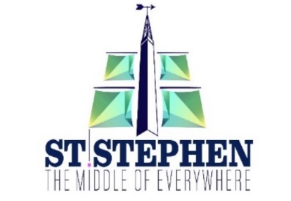

Town of St. Stephen
Special Meeting of Council
Public Hearing of Objections to be held on
Wednesday September 28th, 2022, 5:00 P.M.
In-Person Meeting

PUBLIC HEARING

The Council of the Town of St. Stephen, in compliance with Section 111 of the Community Planning Act of the Province of New Brunswick, intends to hold a Public Hearing of Objections and/or Comments for the proposed consolidated Zoning By-law No. Z-3 on Wednesday September 28th, 2022, 5:00 P.M.

The propose of the Zoning By-law No. Z-3 is to consolidate past map amendments and introduce a series of updates/corrections/changes to the provisions of the current zoning by-law (Z-2).

A copy of Zoning By-law No. Z-3 may be inspected upon request at 22 Budd Ave, St. Stephen, NB, between the hours of 8:00 AM and 4:00 PM, Monday to Friday.

Public participation can take place in Two (2) ways:

#1 Participation in Meeting:
If you would like to provide comments during the public meeting in-person, you are encouraged to register your attendance by emailing info@chocolatetown.ca

#2 Participation Through Letters:
Anyone wishing to offer comments on this proposed By-law may do so writing by noon on September 28th, 2022, either through email to info@chocolatetown.ca or by mail to 22 Budd Ave, St. Stephen, NB E3L 1E9.

