BY-LAW NO. Z-3-01

A BY-LAW TO AMEND BY-LAW NO. Z-3, BEING ZONING BY-LAW FOR THE TOWN OF ST. STEPHEN

BE IT ENACTED by the Council of the Municipal District of St. Stephen as follows:

- By-law No. Z-3, the Zoning By-Law for the Town of St. Stephen, is amended by changing the zone as shown on the Zoning Map attached to the said By-law as Schedule “A” thereof for the lands shown on Schedule “1” attached hereto and forming part hereof from R-2B (Medium Density Residential) Zone to NC (Neighbourhood Commercial) Zone.

Read the first time this day of

Read the second time this day of

Read the third time this day of

_________________________ ___________________________
Allan MacEachern, Mayor Jeff Renaud, Clerk

I, Jeff Renaud, of the Municipal District of St. Stephen, in the County of Charlotte and Province of New Brunswick, District Chief Administrative Officer, DO SOLEMNLY DECLARE:

- THAT I am the Clerk of the Municipal District of St. Stephen, a municipal corporation, and have personal knowledge of the facts herein declared.

- THAT the requirements of Sections 59, 110 and 111 of the Community Planning Act have been complied with in respect to Bylaw No. Z-3-01, A By-law to amend Bylaw No. Z-3, Being the Zoning By-law for the Town of St. Stephen.

- AND I make this solemn declaration conscientiously believing it to be true and knowing that it is of the same force and effect as if made under oath and by virtue of the Evidence Act.

DECLARED before me at the Municipal District
of St. Stephen, in the County of
Charlotte and Province of New
Brunswick, this day of

____________________________
COMMISSIONER OF OATHS Jeff Renaud, Clerk

BY-LAW NO. Z-3-01
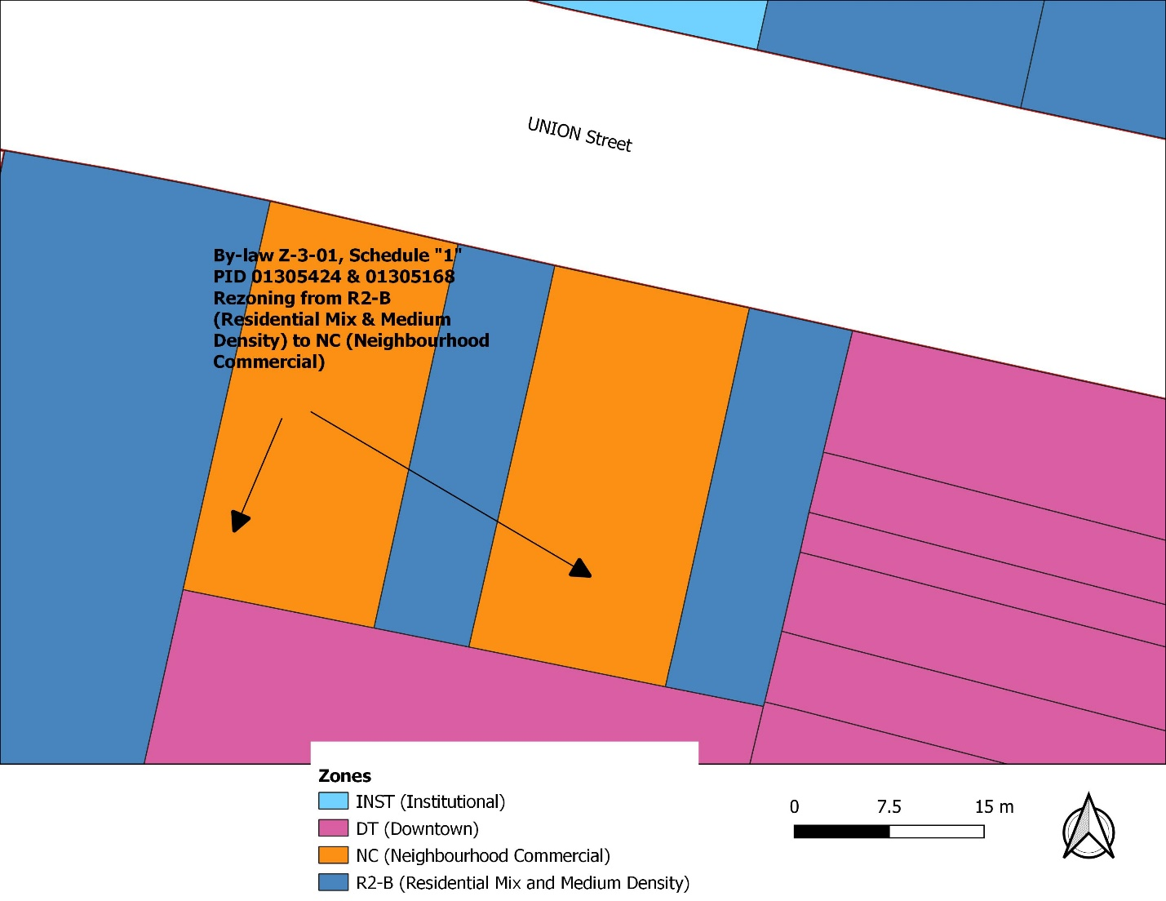
Schedule “A”

