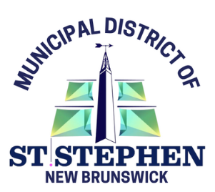

Business/Organization Name: __________________________________________________________
Contact Person: __________________________________________________________ _
Mailing Address: ____________________________________________________________
Phone: ___________________________________________________________ _
Email: ____________________________________________________________
What service or product does your business/organization offer?
______________________________________________________________________________
For specific requests (indoors or outdoors), please explain your needs and we will discuss availability.
______________________________________________________________________________
Total number of 10’ x 10’ spaces required:
Number of booths _____ @ $80.00 plus tax = _______
Electricity required ____ @$20.00 plus tax (note: must supply own extension cords)
Each 10’ x 10’ space includes 1 table & 2 chairs.
The Garcelon Civic Center will not be providing extra tables or chairs. If you require additional tables or chairs, you are welcome to bring your own.
How many organization representatives will be working at your booth over the two-day event? ______________ (Please note you will receive up to 4 free admission bracelets per booth)

I agree to the following vendor terms: ________
(initial)
▪ My booth set-up will be complete by 4pm on Friday May 2nd and I will not tear-down my booth until after 4pm on Saturday May 3rd.
▪ I am aware that a total of 4 representatives of the organization are entitled to free admission per booth to work the booth over the two-day event. Any more than 4 representatives will have to pay the admission fee.
▪ Once registration is complete, MDSS Event staff will assign booths. Request for location will be considered but cannot be confirmed.
▪ Deadline to register is April 21st, 2025.
▪ I am aware there are a limited amount of booths available, and payment of the registration fee, along with receipt of the registration form by MDSS Event Department will secure my booth(s). I’m aware booth availability is first-come, first-served (or waitlist if space permits).
Payment is due in full at time of registration.
Payments can be made by:
Cash, Cheque, Credit, or Debit in person at Garcelon Civic Center. Cheques to be made payable to MDSS and either delivered in person or mail to: MDSS, 22 Budd Avenue, St. Stephen, NB, E3L 2x3.
Online (Visa/Mastercard) Activity search | Chocolate Town (activecommunities.com)

Organization Contact: ____________________________________________________________
Signature: ____________________________________________________________
Date: ____________________________________________________________

Your contact for any questions:
Micchelle Vest, MDSS Event Coordinator, 506-466-7700 ext 125
Patty Anderson, MDSS Event Staff, 506-466-7700 ext 126

