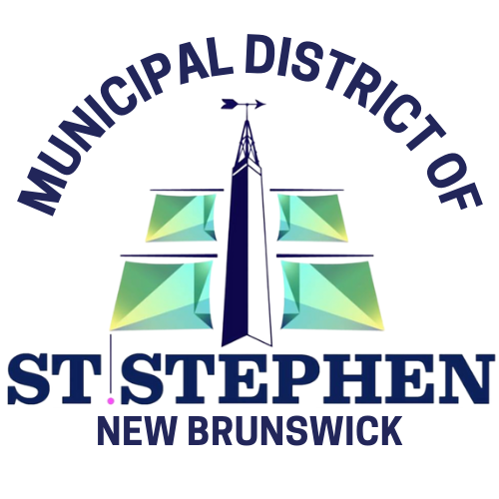

Job Description - The Municipal District of St. Stephen

Job Title: | Utility Operator
Job Type: | Full-Time, Union
Reports To: | Director of Infrastructure – Public Works Supervisor
Work Summary
Performs all assigned duties including operation of Public Works vehicles and machinery, Streets, Utility, and labour work.
Duties and Responsibilities
Under the direction of the Director of Operations and/or Supervisor:
- Operates trucks and other equipment;
- Works on water main transmission lines, laterals, dams, storage facilities, and wells;
- Installs, repairs, and reads meters;
- Installs and repairs fire hydrants;
- Operates pumping station and chlorination building as required by the Utility Approval to Operate;
- Performs or supervises required sampling and testing as required by the Utility Approval to Operate;
- Performs all work assigned including streets and labour work;
- Available for call outs and overtime work as required.
Basic Qualifications
- Minimum Grade 12 or equivalent.
- Experience working in a municipal public works department or related fields will be considered an asset.
- Minimum 2 years experience in the utility operations field.

Additional Training
Distribution courses as required under Section 12 of the Municipal District of St. Stephen’s approval to operate.
Post secondary in Civil or Environmental Technology preferred.
General Requirements
- Must be dependable, flexible, co-operative, and willing to take on the job training and any courses required to operate a Water Utility as regulated by the Municipality and the Department of the Environment.

